Session 2 Homework

BiDirectional Scatter Distribution

Convert pixel resolution to size in steradians. You would want the BSDF over these angles to be less than X amount.

- We wish to specify the scatter quality of a lens for an imager with a pixel resolution of 1 milliradian by 1 milliradian. The scatter source is the sun. In the imager band it puts out about 2mW/cm² at the aperture which has an effective area of 10cm².
  - What is the maximum BSDF allowable for a scatter contribution from the sun of less than 100picowatts, 1 picowatt?
  - How does allowable BTDF scale with Aperture area? (Go back and find definition – essay question)
  - If we put this imager inside an AlON Dome with the BTDF shown, how close can we the sun be to Bore sight and still produce an input of less than 200picowatts to a pixel?
Take the BSD plot and determine what angles you can operate under the conditions. When this problem starts to look easy you understand it.
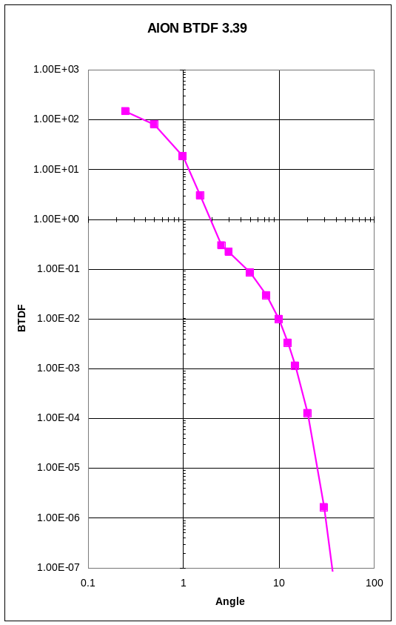

- Assuming the pixels saturate at 4nW/cm², how far off axis does the sun have to be allow a single pixel to be out of saturation assuming a 512 by 512 array when looking though this dome? Assume the pixel size is the same as the first problem 1. The corner pixel is the pixel that will be out of saturation.

- We want to measure the distance between a beam centroid on a screen and the target point. The laser beam has a divergence radius of 1.5 milliradian as defined by its intensity I, given by:

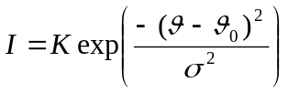

where:
K is an arbitrary constant
θ and θ₀ are measured in milliradians and θ₀ is the beam centroid
σ is the beam divergence equal to 3mrad (diameter).

The beam and screen geometry is as shown.

30°
10°
15°
7m
Camera

The beams are in the plane of this paper as shown except for uniform divergence in and out.,

The beam has a divergence of 3 milliradians (diameter) and is transmitted a distance of 400 meters with negligible initial beam diameter onto a screen 3 meters high by 2 meters in width.
Determine how big this beam is and calculate …? For the purposes of this problem, assume that the beam is hitting the screen square. Beam size is +/- 1 sigma.
For each pixel figure out how much power is in it and figure out the BRDM angle. You don’t have to go through the whole matrix thing from class. You can do this using simple analytic geometry. Then do power on pixel * BRDF, but before you do that, you need to do a couple things. First thing you have to do is you have a certain size spot at a certain range. You need to figure out the focal length of the lens that you need to determine how much of the spot ??hits each pixel??. The angles from the picture will have different BRDF.

Determine what the power distribution is, then what the power distribution appears to be for the camera.

In the picture, the center line coming out of the screen is the normal. The 30deg below level is the angle of the laser.
The imaged optics are set up to image the screen over a 100 by 100 pixel section of the staring focal plane with a pixel pitch of 25μm in both directions, ignore foreshortening to compute the require focal length assuming the unit planes are in the center of the lens.

  - What is the focal length of the lens?
  - Assuming the beam is centered on the screen which is flat and covered with the glossy material shown in the figure (Caution, BRDF is plotted in degrees laser is in milliradians)

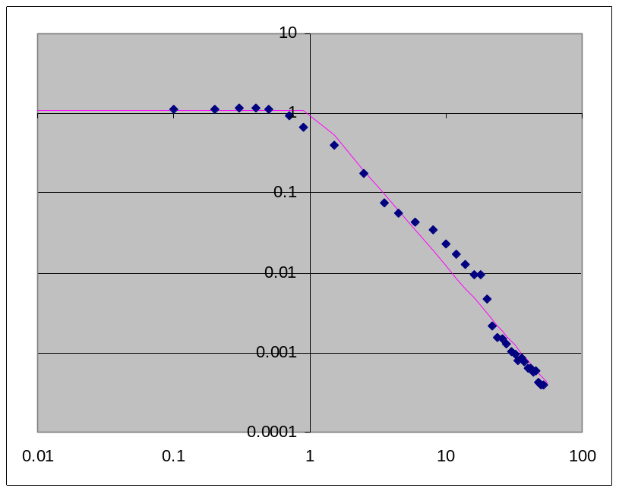

Use the approximation given by the Excel form,
This in Excel is the equation for the bi-directional reflectance. He just copied the equation.

IF(A184<1.2, 1.1,1.1919*A184^(-1.984)) to estimate the backscatter to each pixels and compute the apparent centroid. (X axis is in degrees)
What you have to do is get him a plot of the backscatter intensity on the screen and calculate the centroid. You will see what the centroid error is and see how it is bad to use a glossy screen. After doing it again using the twill you will see how the centroid error decreases.

- Replace the screen covering with twill cloth with the BRDF shown below;
Note: This is plotted linearly rather than log.
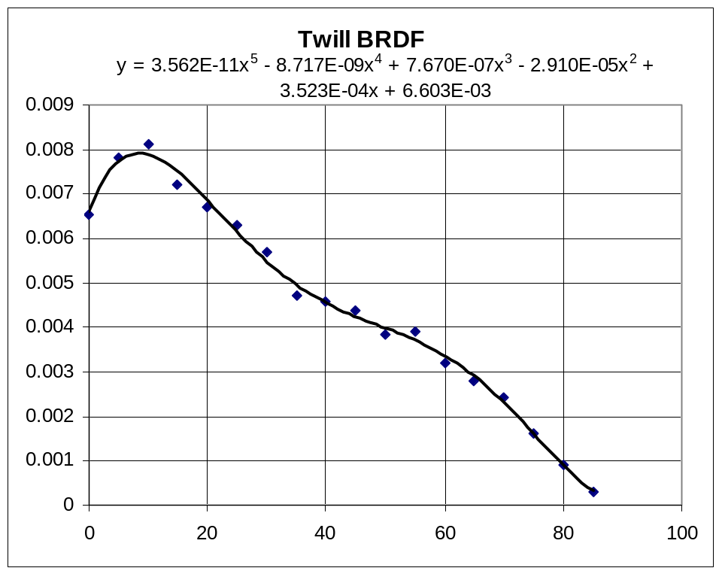
have use the approximation equation at the top of the figure and compute the backscatter in each pixel and compute the apparent centroid. BRDF axis is in degrees.
Question is: how much did this reduce the error?

- We wish to measure bore sight with the test instrument shown below
The first part would be, with all of that information, calculate how much power is coming back into our parabola. This is a straight forward application of bi-directional scatter. The second part is basically a re-run of the problem we had on diffraction. Before he gave you the power and now you need to calculate the power. It is basically the same as last week. Part C is a problem with imaging. He will give us more information on it...? He needs to work through the rest of the problem himself and will make notes. The possibly revised problem and notes will be posted in his public area.

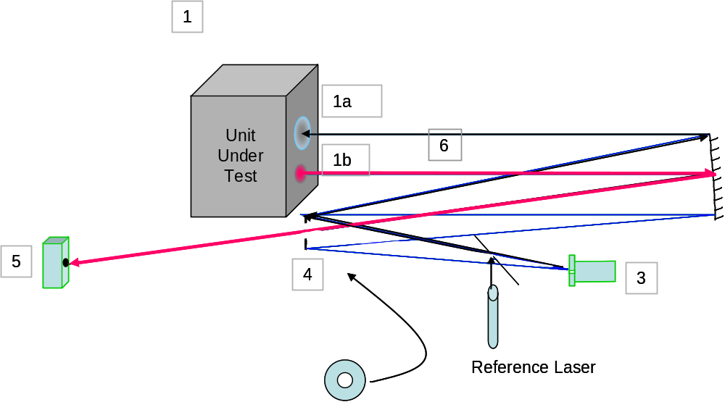

8 meters

(Last problem do not start this until final version is released)

The unit under test is IPS (Invisible Protective Shield) Modular Infrared System to Make Missiles Miss (MISMMM) Mark I
- The MISMMM is 8 meters from the off axis Paraboloid
- Its jam laser puts out 10 Watts at 4.00λm
- Its laser aperture is 1 cm in diameter
- Its tracker aperture is 3 cm in diameter
- The tracker gate is 6 milliradians by 6 milliradians centered on the tracker bore sight.
- The aperture centers are 4 cm apart
- The tracker band pass includes the laser wavelength The off axis parabola is 15° off axis with a focal length of 1.25M
- For this problem treat the aperture at mirror 4 in the figure above as being at the paraboloid surface with a hole of radius 2.5cm. Usually we convert W/sr to W/cm² by dividing the scattered power by the square of the collimator focal length in cm.

  - Given the BRDF for the camera focal plane as shown below estimate using BRDF how much laser power scatters back toward the paraboloid.

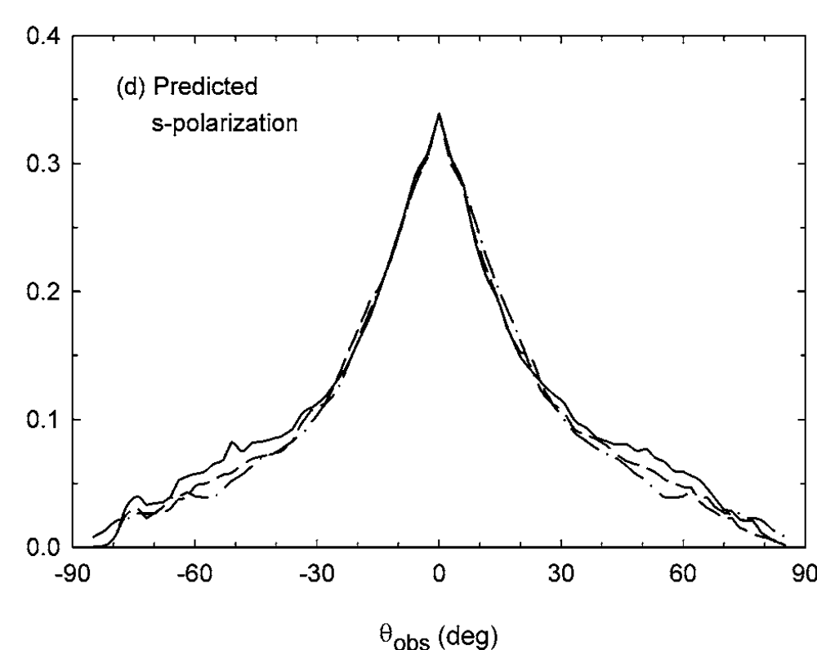
The Vertical axis is BRDF in Sr-1. (This data was measured for silicon measured at 0.635μm by Qunzhi Z. Zhu and Zhuomin M. Zhang Optical Engineering “Correlation of angle-resolved light scattering with the microfacet orientation of rough silicon surfaces” 44, 7 , 073601 July 2005 we shall assume that BRDF does not depend on wavelength, although it really does). Use the highest value of the three curves at the appropriate value of θ_{obs}. Finding the value of θ_{obs} is the exercise for the student.

  - The solid angle for the scattered power is that of the collimator as defined by the aperture. Approximate the returned laser power as a plane wave emerging and diffracting from the center aperture. Estimate the power in W/cm² at the tracker aperture assuming that the MISMMM has successfully pointed itself at the reference and the jam laser is pointed along the collimator axis and the beam is centered on the hole in M4. (You will have to evaluate the Fresnel Integral at points corresponding the tracker aperture)
  - Assume all of this power is from the aperture which is 8 meters away and above the tracker axis as described above. Is its image inside the tracker window?
  - In the tracker band the source emits about 0.03W/cm²sr. In this case the area is the hole in the black body and the solid angle in sr/cm² is the inverse square of the collimator focal length. We typically assume that this is the power in W/cm² at the tracker aperture. The Black body aperture is 0.75mm by 0.75mm What is this power density (w/cm²) from the part of the collimator mirror it can reach?
  - What is the divergence (in milliradians) of the black body radiation from the collimator mirror.
  - Given that for self tracking to occur the augmented return has to be in the tracker window and comparable to the power of the reference source, is this test set up susceptible to self tracking.

